A taxonomy of temporal data visualization techniques
Chaouki Daassi, Laurence Nigay, Marie-Christine Fauvet
Laboratoire CLIPS-IMAG, Grenoble, France
[Chaouki.Daassi, Laurence.Nigay, Marie-Christine.Fauvet]@imag.fr
Résumé
Plusieurs techniques de visualisation et d’interaction avec des espaces de données temporelles ont été proposées dans la littérature. Toutes ces techniques ont été conçues indépendamment les unes des autres. Dans ce contexte, il est difficile d’explorer l’ensemble des possibilités de conception de ce type de technique de visualisation. En adressant ce problème, ce papier présente une taxonomie des techniques de visualisation de données temporelles. Sur la base de l’étude de trente sept techniques et systèmes de visualisation de données temporelles, notre taxonomie structure l’espace de conception selon les étapes du processus de visualisation de Chi.
Mots clés : Techniques de Visualisation, Données Temporelles, Processus de Visualisation, Taxonomie.
Abstract
A wide range of visualization techniques have been designed to assist the users to visually analyze and manipulate temporal data. All the techniques have been designed independently. In such a context it is therefore difficult to systematically explore the set of possibilities as well as to thoroughly envision visualization techniques of temporal data. Addressing this problem, we present a taxonomy of visualization techniques of temporal data. Based on a study of thirty-seven visual tools and visualization techniques of temporal data, our taxonomy structures the design space according to the Chi's visualization process steps.
Keywords: Visualization Techniques, Temporal Data, Visualization Process, Taxonomy.
- Introduction
Temporal data denote the evolution of an object attribute over a time interval. It could be viewed as a collection of instant-stamped time or interval-stamped time of data items [10].The values of temporal data are called a history. Examples of quantitative temporal data are the history of an employee’s salary or daily productions of a firm. The data values represent the structural dimension of the data, and the time values represent the temporal dimension of the data. A temporal data set is then an association between a structural dimension and a temporal dimension.
Several visualization techniques of temporal data have been proposed in different application domains: display of clinical data [24], display of geographical data [18], display of hydrometric data [16], display of personal histories [20], and for different purposes as for searching trends and patterns [11], exploring program traces [22], analyzing log data [12], representing temporal abstractions [25] or visualizing temporal association rules [21]. All the techniques have been designed independently. Consequently, it is difficult to systematically explore the set of possibilities as well as to thoroughly envision visualization techniques of temporal data. In such a context we need a taxonomy to gain understanding of the design of such techniques and then reduce the time and effort. In this paper we present a taxonomy of techniques dedicated to temporal data visualization. The originality of our taxonomy is that the classification criterion is based on the steps of Chi’s visualization process.
The rest of the paper is organized as follows. First (in Section 2), we briefly describe the Chi’s visualization process. In section 3, we show how Chi’s visualization process can be applied to temporal data. We then present in Section 4 our taxonomy of temporal data visualization techniques. Finally we conclude and present future work.
- Ed Chi’s visualization process
As shown in Fig. 1, Chi [4] decomposes the visualization process into three types of transformations manipulating four types of data. In this paper, we structure the visualization process of Chi into four steps namely: (1) data, (2) point of view on the data, (3) visualization space and (4) point of view on the visualization space.
Data. This step is related to the data to be visualized. In the example of Fig. 1 the data is a set of URLs. We distinguish the two dimensions of a temporal data: structural dimension and temporal dimension. The structural dimension is characterized by a given data type. In particular, we distinguish one-dimensional, two-dimensional, three-dimensional and multi-dimensional data. One-dimensional data could be either quantitative, nominal or ordered. Two-dimensional data are for example images or geographical maps. Three-dimensional data are for example real world objects. Multi-dimensional data are sets of data consisting of N variables (each variable corresponds to one dimension of the data) that can be completely inter-related or completely independent.




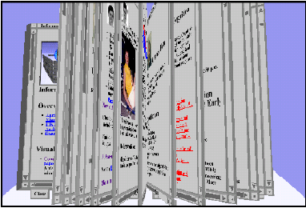
a. Chi’s decomposition b. Four steps of a visualization process

a. Ed Chi’s decomposition b. Four steps of a visualization process

a. Ed Chi’s decomposition b. Four steps of a visualization process

a. Ed Chi’s decomposition b. Four steps of a visualization process

a. Chi’s decomposition b. Four steps of a visualization process

a. Ed Chi’s decomposition b. Four steps of a visualization process

a. Ed Chi’s decomposition b. Four steps of a visualization process

a. Ed Chi’s decomposition b. Four steps of a visualization process
Example:

Example

Example

Example

Example:

Example

Example

Example
Steps:

Steps :

Steps :

Steps :

Steps:

Steps :

Steps :

Steps :
Value

Data Transformation

Visualization
Transformation

Visualization Abstraction

Visual mapping Transformation

View

Point of view on the data (PVD)

Visualization Space

Point of view on the visualization space (PVS)

http://book.imag.fr/p1.html, …,
http://book.imag.fr/pN.html

http://book.imag.fr/page1.html, ….,
http://book.imag.fr/pageN.html

http://book.imag.fr/page1.html, ….,
http://book.imag.fr/pageN.html

http://book.imag.fr/page1.html, ….,
http://book.imag.fr/pageN.html

http://book.imag.fr/page1.html, ….,
http://book.imag.fr/pageN.html

http://book.imag.fr/page1.html, ….,
http://book.imag.fr/pageN.html

http://book.imag.fr/page1.html, ….,
http://book.imag.fr/pageN.html

http://book.imag.fr/page1.html, ….,
http://book.imag.fr/pageN.html
Analytical Abstraction

Data

- Chi visualization process.
Point of view on the data. At this stage, the data are transformed onto an analytical representation. This transformation is generally dependent on the data structures. Indeed the point of view on the data is obtained by defining an analytical abstraction, in other words by obtaining meta-information related to the data such as their organization (hierarchical, sequential, etc.). For example, in Fig. 1, the web pages are retrieved from the list of URLs, then an image is generated for each web page.
Visualization space. This step is defined by a transformation of visualization which maps an analytical representation onto values ready to be displayed. In the example of Fig. 1, the images (the point of view on the data) are ordered (ordered list of images). Moreover, this transformation fixes the characteristics of the graphical space in which the data are visualized such as the number of its dimensions.
Point of view on the visualization space. This step produces the perceptible rendering. It results from a visual mapping transformation which maps the directly displayable values onto a view. In the example of Fig. 1, a book is defined for presenting the list of web pages. So, at the visualization space step, the designer decides on the characteristics of the graphical space. According to these characteristics, the data values of the previous step are mapped onto graphical signs.
In addition to the decomposition of the visualization process into three types of transformations manipulating four types of data, Chi defines operators. Operators for the “data” step are for example data filtering and adding new sets of data. Operators for the “point of view on the visualization space” step include rotation, translation and enlargement of graphical objects. Other operators are defined for the two steps “point of view on data” and “visualization space”.
Having presented the Chi’s visualization process, we now apply this process to visualize temporal data.
- Visualization process of temporal data
As defined above, a temporal data set is an association between two dimensions: a structural dimension and a temporal dimension. Based on these two dimensions, we define the visualization process of a temporal data space as an association between two visualization processes dedicated to the two dimensions of the temporal data. The visualization process of the structural dimension is dependent on the type of data. Studying this process consists of studying the visualization process of data in general, which is out of the scope of this paper. We therefore only focus on the visualization process of the temporal dimension. Fig. 2 shows how we apply the Chi’s visualization process to the temporal dimension of temporal data: four steps are defined namely time, point of view on time, time space and point of view on the time space.
Time. This step represents the time values to be visualized. Time values are observed according to a time unit as Year, Month, Day, Hour, etc. In the example of Fig. 2, time values are observed according to the Day time unit.

Steps:
Temporal values
Transformation of temporal values
Analytical Abstraction
Visualization
Transformation
Visual mapping Transformation

Time view
Time
Point of view on time
Time space
Point of view on the time space
Visualization Abstraction
Example:
Month
Year
Day
Multi-granular and linear
01/09/2000, 01/10/2000,
01/11/2000, … 02/26/2003

Month
Year
Day
Year

- Visualization process of a temporal dimension.
Point of view on time. As explained above, this step is defined by the transformation of the time values. This transformation extracts from the time values how time is represented: (i) in which unit system the time values are expressed (ii) are time values linear or periodic? In the example of Fig. 2, time is considered as multi-granular and linear. Multi-granularity refers to time units composition: a year is composed of twelve months, a month is composed of 28, 29, 30 or 31 days, and so on.
Time space. At this step, displayable space of the time values is defined. For example, time values observed at the unit Hour (the analytical representation of “the point of view on time” step), could be mapped onto a matrix. One dimension of the matrix represents the days (Day is a unit coarser than Hour, and regular with Hour), while the other represents the hours. In the example of Fig. 2, each time unit is considered as linear: one time axis is then associated to each of them.
Point of view on the time space. The point of view on the time space refers to the perceptible rendering of the temporal dimension. At this step, the perceptible forms of time are implemented. These forms must be studied according to the human perception of time.
The choice of a form is strongly influenced by the point of view on time that has been adopted (Step 2 “Point of view on time”). Indeed, the point of view on time identifies the characteristics of the temporal values to be visualized. For example, a graphical representation of time in a cyclic form as illustrated by the spiral shown in Fig. 3a could be used because the temporal values are periodic: periodicity is a characteristic that has been identified during the step “Point of view on time”. The Fig. 3a shows data on the consumption of Baphia Capparidifolia by chimpanzees in the Gombe preserve in Tanzania for the years 1980 through 1988. Data values are mapped into blue colored circles: the size of these circles shows the difference in the quantity of the consumption at each month. Fig. 3b (a simplified representation of the TimeSlider technique [15]) illustrates yet another representation of time where points of time are distributed irregularly on an axis in order to render a logarithmic perception of time [5]. As shown in Fig. 3b, time scale is linear at the center part of the timeline (time step is uniform and equal to one time unit, a day in Fig. 3b) whereas it is non-linear (time step is exponential) at the ends. Time may be viewed as linear as depicted in Fig. 2. In the example of Fig. 2, four timelines [9] are used to interact with the time space: one timeline for each time unit.
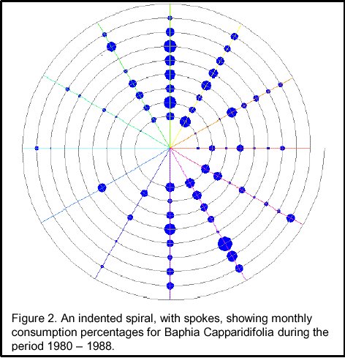
a. Spiral representation of time [3]
b. TimeSlider [15]
Time scale
linear
Non linear
Non linear
9
16
20
23

25
26
27
28
3/1
2
3
5
8
12

- Time representations.

Some visualization techniques rely on several forms of time used simultaneously. The Spiral Calendar Visualizer [19] of Fig. 4 includes two points of view on time: multi-granular and cyclic. In Fig. 4, the values of each time unit are represented as a calendar (multi-granular representation of time). Thus, years are first represented in a view, then one year (1993 in the example of Fig. 4) is displayed in another view and a month of this year is displayed in another view and so on. All the views are represented in a spiral form (cyclic perception of time). Using simultaneously these two forms of time reinforces the user’s perception of the multi-granular structure of time while highlighting cycles.
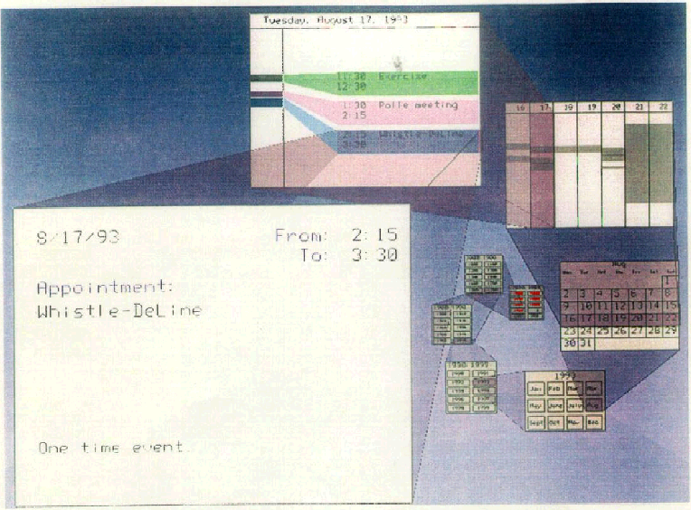

- Spiral Calendar Visualizer [19].
- A taxonomy based on the steps of the visualization process
Our taxonomy of temporal data visualization techniques is based on the different anchoring points between the visualization process of the temporal dimension (as described in the previous paragraph) and that of the structural dimension. Considering the different anchoring points between the two visualization processes enables us to define seven classes of visualization techniques, described in Fig. 5. These configurations vary in between two opposite cases: the complete fusion of the processes (Fig. 5a) and the complete splitting of the processes (Fig. 5g).
A point of contact between the two visualization processes is defined according to the operators that are applied at the corresponding step. The operators, as defined by Chi, are specific to each of the four visualization process steps. For example translation or rotation are operators dedicated to the step “point of view on the visualization space”. If at a given step, one operator has an impact on the data manipulated by the two processes then we consider that the corresponding step is the point of contact. One operator is a sufficient condition to declare the corresponding step point of contact. It is worth noting that some operators may remain specific to only one of the two processes. Once a step is defined as the point of contact, all the following steps in both processes are then merged.
Data

Point of view on the data (PVD)

Visualization Space

Point of view on the visualization space (PVS)

a
Temporal data
f
Data
Time
g
Data
Time
Data
Time
b
c
Data
Time

e
Data
Time
d
Data
Time

- Five classes of temporal data visualization techniques according to their visualization process.
Total fusion or fusion at the step “point of view on the data”. Some visualization techniques of temporal data result from a complete fusion of the two visualization processes. We distinguish two cases described in Fig. 5a and Fig. 5b. The configuration depicted in Fig. 5a is often used to visualize data whose temporal field is implicit: the representation of time is then implicit. Examples include playing videos, or visualizing data captured in real time. By opposition, the configuration shown in Fig. 5b is used to visualize temporal data whose temporal field is explicit. Time is then explicit, enabling us to distinguish the two dimensions of temporal data, the temporal and structural ones. Visualization techniques could then be split depending on whether the time representation is explicit (Fig. 5b) or implicit (Fig. 5a).
The first class gathers together the techniques which include an explicit representation of time. For example, the diagram representations which are usually used to visualize quantitative data, or temporal intervals and temporal relations [17] [23]. In this type of representations, time is often represented on the horizontal axis and data values on the vertical axis. In the example of Fig. 6, the technique visualizes the air pollution measures over time of NO (nitric oxide) and NO2 (nitrogen dioxide). Structural values are represented as a curve.
Time
Data values
NOconcentration
NO2concentration

- Curve Representation.
Fig. 7 presents the visualization process (configuration b of Fig. 5) of the curve representation: the visualization process of the temporal dimension and that of the structural dimension are crossing at the “point of view on the data”. Consequently, the representation of the structural dimension (the curve) and that of the temporal dimension (the time axis) are in the same graphical space. In the example of Fig. 6, the two dimensions are visualized within a two-dimensional graphical space. In the visualization process of the temporal dimension of Fig. 7, time is implicitly considered as linear. The linear perception of time is used to guide the design of the representation of time values as an axis.

Point of view on the visualization space

Time
Curve representation
Visualization space
Point of view on the data
Curve
Quantitative
Structural dimension
NO or NO2
Temporal values

- Visualization process of Curve Representation.
The second class groups the visualization techniques whose representation of the temporal dimension is not explicit. We distinguish two categories of techniques that belong to this class: dynamic representations vs static representations. The former groups techniques for which the visual representation is time-dependent: it changes dynamically and is a function of time. Campos and al. [2] propose an animation model to support exploratory analysis of dynamic environments. Animation is frequently used to visualize spatio-temporal data as with the TimeMap data viewer [13]. The later groups techniques for which the visual representation does not change automatically over time.
The information mural technique [14] is a static representation of temporal data that belongs to this class. It allows us to visualize a large data space: the number of data values is greater than the number of pixels available in the screen. This technique transforms the initial data space which is defined with M*N pixels into a smaller space of I*J pixels while preserving a similar global view of the initial data space. Based on this technique, Fig. 8 presents a visualization of the number of daily recorded sun spots observed between 1850 and 1993 which is over 52,000 readings. As a temporal dimension is not explicitly represented, both the “time space” and the “point of view on the time space” steps of the temporal dimension visualization process are not considered.

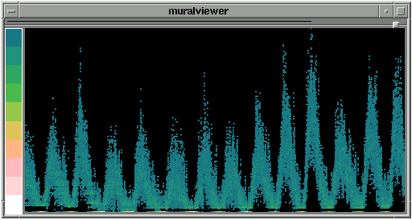

- Information Mural [14].
Fusion at the step “visualization space”. The fusion of the two visualization processes at the step “visualization space” (Fig. 5c) implies that the graphical space of the structural dimension depends on the temporal dimension. Thus, the characteristics of the graphical space of the temporal dimension and some operators applied on this dimension, directly affect the graphical space of the structural dimension, and conversely. We distinguish two classes of visualization techniques defined by the process of Fig. 5c according to whether the graphical space of the structural dimension is merged with the graphical space of the temporal dimension, or not.
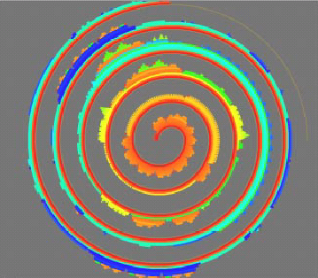

- Spiral representation [22].
In the first class, there is one single space representing the two dimensions. If the temporal dimension (respectively the structural dimension) is represented in a three-dimensional space, the structural dimension (respectively the temporal dimension) must then be represented in a three-dimensional space. As the two graphical spaces are merged, the visual discontinuity between the two dimension representations is reduced. The Spiral representation [22] of Fig. 9 is an example of technique that belongs to this group, its visualization process is presented in Fig. 10. Fig. 9 shows a visualization of program traces over time.
As shown in Fig. 10, the visualization process of the structural dimension and that of the temporal dimension are crossing at the visualization space step. In the visualization process of the temporal dimension of Fig. 10, only the cyclic perception of time is considered at the point of view on time step. Consequently time is represented as a spiral. As we can see from Fig. 9, the structural dimension and the temporal dimension are visualized into the same graphical space, in particular a two-dimensional graphical space.
Point of view on the visualization space

Point of view on time
Time
Spiral representation
Visualization space
Point of view on the structural dimension
Spiral
Quantitative
Structural dimension
Program traces
Cyclic
Temporal values

- Visualization process of the Spiral representation.
In the second class of techniques, the two dimensions are represented separately in the same graphical space. For example, our TimeVis technique of Fig. 11 distinguishes the representation of the time from the representation of the structural values. Time and structural values are separately represented but in the same graphical space. As for the example given in Fig. 9, rotating the representation (graphical space) of the temporal dimension (the perspective wall timeline in the example of Fig. 11) implies a rotation of the representation (graphical space) of the structural dimension. In the example of Fig. 11, the TimeVis technique shows the history of the investments (in millions of dollars) of one country in agriculture, services and industries.

Agriculture : 250M
Services : 180M
Industries : 460M

Agriculture : 258M
Services : 270M
Industries : 450M

Agriculture : 260M
Services : 203M
Industries : 380M

Agriculture : 258M
Services : 290M
Industries : 650M

Agriculture : 200M
Services : 120M
Industries : 450M

- TimeVis technique.
Fusion at the step “point of view on the visualization space”. This configuration (Fig. 5d) of the two visualization processes is impossible. In fact, the structural values are always associated with the temporal values, which implies that the point of view on the visualization space of the structural dimension is defined only once the point of view on the time space is defined. Thus, the two points of view on the visualization spaces must be fixed sequentially, considering first the time and then the structural values. Respecting this ordering constraint we identify two cases depicted in Fig. 5e and Fig. 5f.
Time and then the step “visualization space of the structural dimension”. Some visualization techniques of temporal data use the graphical space of the temporal dimension as a support for the representation of the structural dimension. The main advantage is the direct association of structural values with the corresponding temporal values. This direct association reduces the visual discontinuity between both representations. As a result, the temporal values and the structural values are visualized in the same graphical space. First, the characteristics of this graphical space are all fixed by the temporal dimension and second, the structural values are then visualized within this space. If time is represented in a two-dimensional space, the structural values will be too. For this reason, the representation of the structural dimension is defined once the visualization process of time is completely achieved (see Fig. 5e). It is worth noting that this configuration is different from that where the fusion proceeds at the “visualization space” step (see Fig. 5c). Indeed, based on this configuration, the visualization process of the temporal dimension is completely independent of that of the structural dimension. This later could be modified or replaced by another one while keeping the same visualization process of the temporal dimension.
The Superposed Histograms Technique (SHT) [6] of Fig. 12 illustrates this configuration of visualization process. In SHT, data values (air pollution measures of NO and NO2 in the example of Fig. 12) have been mapped to 2.5D graphical objects (in the form of cubes). Time is represented along two dimensions. For this reason, the SHT includes two time-sliders, one vertical and one horizontal.
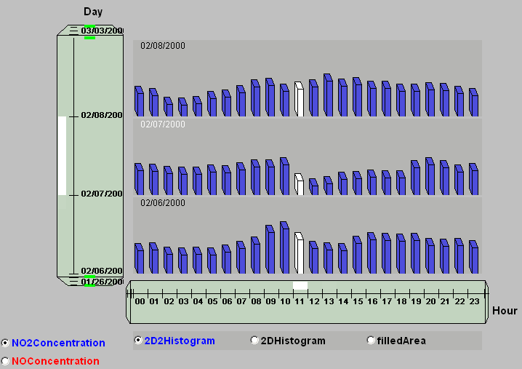

- Superposed Histograms technique [6].
As shown in Fig. 13, we distinguish two visualization processes: one dedicated to the temporal dimension and one dedicated to the structural dimension. The visualization process of the temporal dimension of the SHT is completely achieved independently from that of the structural dimension, whereas the opposite is not no true. In the visualization process of the temporal dimension of Fig. 13, two time perceptions are considered at the point of view on time step: multi-granular and linear perceptions. The linear perception of time is used to guide the design of the perspective wall timeline, whereas the multi-granular perception implies the use of two timelines: one to represent hours horizontally and one to represent days vertically.
As we can see from Fig. 13, during the visualization space step of the structural dimension, a histogram is used to denote the evolution of the visualized data. The choice of the histogram representation is strongly influenced by the fact that the data are quantitative. Moreover, histograms are visualized within a two-dimensional graphical space. In fact, as shown in Fig. 13, the structural space is defined with respect to the characteristics fixed within the time space step (the arrow coming from the point of view on time space to the structural space). In the SHT technique time is represented within a two dimension graphical space.
Time space
Point of view on the visualization space

Point of view on the time space
Point of view on time
Time
Temporal values
Perspective wall form
Two perspective wall representations
Superposed Histograms Technique
Structural space
Point of view on the structural dimension
Histogram form
Quantitative
Structural dimension
NO or NO2
Linear
Two dimensions of the time space
Multi-granular

- Visualization process of Superposed Histograms Technique.
Time and then the step “point of view on the visualization space of the structural dimension”. The process corresponding to this case is shown in Fig. 5f. The temporal dimension is visualized in a graphical space independent of the structural dimension. On the one hand this distinction allows an explicit separation between the user tasks referring to each of the two dimensions of temporal data, for example by navigating in time versus navigating along the structural dimension. On the other hand visual discontinuity is possible, for example making difficult the identification of a value at a given time. The Star Representation Technique (SRT) [8] of Fig. 14 illustrates the process of Fig. 5f.
As shown in Fig. 15, we distinguish two visualization processes: one dedicated to the temporal dimension and one dedicated to the structural dimension. The visualization process of the temporal dimension of the SRT is completely achieved independently from that of the structural dimension, whereas the opposite is not no true.
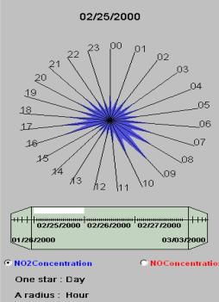
Perspective
Wall Timeline
Star representation

- Star representation technique [8].
As shown in Fig. 14, the SRT technique relies on two forms of time used simultaneously (the perspective wall timeline and the star representation). In the visualization process of the temporal dimension of Fig. 15, three time perceptions are considered at the point of view on time step: multi-granular, linear and periodic perceptions. The multi-granular perception is used to distinguish hours and days. The linear perception of time is used to visualize days as a perspective wall timeline, whereas the periodic perception is used to visualize hours of a day and thus to design the structural space, the star representation of Fig. 14. In Fig. 14, a star denotes a day whereas the radii denotes the twenty four hours of a day.
During the visualization space step of the structural dimension, a star representation is used to denote the evolution of the visualized history during a fixed-length period of time. The choice of the star representation is strongly influenced by the fact that we considered the periodic perception of time to define the visualization space (the arrow coming from the point of view on time to the structural space) and by the fact that the data are quantitative (the NO and NO2 concentrations). The star representation could be visualized within a two dimension graphical space as in the example of Fig. 14 or within a three dimension graphical space. By opposition to the superposed histograms technique of the precedent paragraph, as shown in Fig. 13, the structural space is defined independently from the characteristics of the time space. In fact, there is no connection between either the time space or the point of view on time space where the characteristics of the graphical space are fixed, and the structural space.
Point of view on the visualization space

Point of view on the time space
Time space
Point of view on time
Time
Perspective wall form
Perspective wall representation
Periodic
Star Visualization Technique
Structural space
Point of view on the structural dimension
Quantitative
Structural dimension
NO or NO2
Linear
Temporal values
Star form
Multi-granular

- Visualization process of Star Visualization Technique.
Process completely separated. Such a configuration (Fig. 5g) is impossible as the structural values are always associated with the temporal values.
- Discussion and future work
As the temporal dimension is designed independently from the structural dimension in the visualization processes of Fig. 5e and Fig. 5f, our resulting perspective wall timeline (produced by the visualization process of temporal dimension) has been reused in the Superposed Histograms Technique and the Star Representation Technique. Consequently we can use a dedicated physical device [7] (as shown in Fig. 16) for the perspective wall timeline, making the reusable corresponding software component a reusable physical device. Our physical device corresponds to the perspective wall timeline associated with a handheld computer. The Star Representation Technique will consequently be multi-surface, one for the temporal dimension and one for the structural dimension. This is more complicated to implement for the Superposed Histograms Technique because it uses two timelines to represent the time space. Perhaps, it is not possible to use the physical device with the Curve Representation of Fig. 6: the fusion of the two visualization processes is at the step “point of view on the data”. The representation of the structural dimension and that of the temporal dimension are then in the same graphical space. Consequently, they are visualized on the same display, a screen for example.
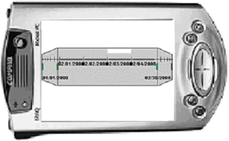

- Physical device to interact with the temporal dimension [7].
Our taxonomy of temporal data visualization techniques is based on the possible points of contact between two visualization processes, one dedicated to the temporal dimension and one to the structural dimension. This study could be generalized to any type of data by considering the visualization of two data spaces or coordinated and multiple views of the same data space. However, for the case of temporal data, the two data spaces are linked: indeed the structural values are stamped by temporal values. For the case of two independent data spaces, additional configurations should be considered. For instance, the configuration of Fig. 5d which is impossible for temporal data, becomes possible for two independent data spaces.
- References
- C. Antunes and A.-L Oliveira, Temporal Data Mining: an Overview. In KDD Workshop on Temporal Data Mining, August 2001.
- J. Campos, M.-J. Egenhofer and K. Hornsby. Animation model to Support Exploratory Analysis of Dynamic Environments. In proceedings of Summer Computer Simulation Conference (SCSC), Canada pages 761-766, July 2003.
- J.-V. Carlis and J.-A. Konston. Interactive Visualisation of Serial Periodic Data. In proceedings of User Interface Software and Technologie UIST, San Francisco, Ca, 1998.
- E.-H. Chi. A Taxonomy of Visualization Techniques using the Data State Reference Model. Proceedings of InfoVis 2000 (Salt Lake City UT, October 2000), IEEE Computer Society.
- R.-M Church. Evaluation of Quantitative Theories of Timing. Journal of the experimental analysis of behavior. Number 2, March 1999.
- C. Daassi, M.-C. Fauvet, L. Nigay. Visual Mining: Representation Multiplicity of Temporal Data. In proceedings of DEXA, Septembre 2-6, 2002, Aix-en-Provence, France.
- C. Daassi, M.-C. Fauvet, L. Nigay. Composant logiciel vs physique pour interagir avec un espace de valeurs temporelles. French Conference on Human Computer Interaction, Namur, Belgium, 2004.
- C. Daassi, M.-C. Fauvet, L. Nigay. Visualization process of Temporal Data. In proceedings of DEXA Conference, Spain, 2004.
- M. Dumas, C. Daassi, M.-C. Fauvet, L. Nigay. "Pointwise Temporal Object Database Browsing". In Proc. Of ECOOP, France, 2000.
- M.-C. Fauvet, M. Dumas, and P-C. Scholl. A representation independent temporal extension of ODMG´s Object Query Language. In proceedings of BDA Conference, Bordeaux, France, October 1999.
- S. Havre, B. Hetzler and L. Nowell. ThemeRiver: Visualizing Theme changes over Time. Proceedings of the IEEE Symposium on Information Visualization 2000.
- H. Hochheiser, B. Shneiderman. Using Interactive Visualizations of WWW Log Data to Characterize Access Patterns and Inform Site Design. In proceedings of Journal of the American Society of Information Science and Technology, Vol. 52, No. 4, 2001.
- J. Ian et A.Wilson. The TimeMap Project: Developing Time-Based GIS Display for Cultural Data. Journal of GIS in Archaeology Vol 1. ESRI Inc., Redlands. 2002.
- D.-F. Jerding et J.-T. Stasko. The Information Mural : A Technique for Displaying and Navigating Large Information Spaces. Technical Report GIT-GVU-97-24, Graphics, Visualization, and Usability Center, Georgia Institute of Technology.
- K. Yuichi, S. Atsushi et K. Yoshiyuki. TimeSlider : An Interface to Specify Time Point. In proceedings of UIST 1997, Alberta Canada.
- T. Kramer and J. Jozsa. Visualization and analysis of time-dependent hydrometric data in windows environment. In proceedings of Hydroinformatics, August 1998.
- L. Chittaro and C. Combi. Representation of Temporal Intervals and Relations: Information Visualization Aspects and their Evaluation. In Proceedings of TIME: 8th International Symposium on Temporal Representation and Reasoning, IEEE Press, 2001.
- A.-M. MacEachren, F.-P Bosco, D. Haug, L.-W. Pickle. Geographic Visualization: Designing Manipulable Maps for Exploring Temporally Varying Georeferenced Statistics. Proceedings of Information Visualization, Oct. 19-20, 1998.
- J-D Mackinlay, G. Robertson, et R. DeLine. Developing Calendar Visualizers for the Information Visualizer. In proceedings of UIST 1994.
- Plaisant C., Milash B., Rose A., Widoff S. and Shneiderman Ben. LifeLines : Visualizing Personal Histories. In proceedings of CHI’96. Vancouver, BC, Canada, April 13-18, 1996.
- Rainsford Chris P. and Roddick John F. Visualisation of Temporal Association Rules. In proceedings of 2nd International Conference on Intelligent Data Engineering and Automated Learning (IDEAL), 2000.
- Renieris M. et Reiss S. P. ALMOST : Exploring Program Traces. NPIVM' 99 Workshop, Kansas City, MO, November 6, 1999.
- R. Kosara, S. Miksch. Visualizing Complex Notions of Time. Proceedings of the Conference on Medical Informatics, 2001.
- Y. Shahar and C. Cheng. Intelligent Visualization and Exploration of Time-Oriented Clinical Data. In Proceedings of Topics in Health Information Management, 1999.
- Y. Shahar and C. Cheng. Model-Based Visualization of Temporal Abstractions. In Proceedings of Computational Intelligence, 2000.

One time-unit U1 is said to be regular with regard to another time-unit U2, only if each value of U1 is composed of a fixed number of U2. The time unit U1 is said to be coarser than the time unit U2, and U2 is finer than U1. A concrete example of regular units is Year (coarser unit) and Month (finer unit). Each year contains twelve months.

