Interaction techniques with temporal data:

a taxonomy based on the visualization process
Chaouki Daassi, Laurence Nigay, Marie-Christine Fauvet
Laboratoire CLIPS-IMAG, Grenoble, France
[Chaouki.Daassi, Laurence.Nigay, Marie-Christine.Fauvet]@imag.fr

Abstract
Temporal data are abundantly present in many application domains such as banking, financial, clinical, geographical applications and so on. Temporal data have been extensively studied from data mining and database perspectives. Complementary to these studies, our work focuses on the visualization techniques of temporal data: a wide range of visualization techniques have been designed to assist the users to visually analyze and manipulate temporal data. All the techniques have been designed independently. In such a context it is therefore difficult to systematically explore the set of possibilities as well as to thoroughly envision visualization techniques of temporal data. Addressing this problem, we present a taxonomy of visualization techniques of temporal data. Based on a study of thirty-seven visual tools and visualization techniques of temporal data, our taxonomy structures the design space according to the Chi's visualization process steps. By identifying and organizing the various aspects of design, our taxonomy should also help the designer to address the right design questions and to envision future systems.
Keywords: Visualization Techniques, Temporal Data, Visualization Process, Taxonomy.

Introduction
Temporal data are abundantly present in many application domains such as banking, financial, clinical, geographical applications and so on. Temporal data denote the evolution of an object attribute over a time interval. It could be viewed as a collection of instant-stamped time or interval-stamped time of data items [22].The values of temporal data are called a history. Examples of quantitative temporal data are the history of an employee’s salary, daily productions of a firm, monthly consumptions of electricity of a city, etc. The data values represent the structural dimension of the data, and the time values represent the temporal dimension of the data. A temporal data set is then an association between a structural dimension and a temporal dimension. The structural dimension is characterized by a given data type. For example, it could be either images, quantitative values, or complex objects. The temporal dimension is defined by a calendar which fixes the observation unit. Examples of time units are Year, Month or Day.
Temporal data can be analyzed using statistical tools. Many algorithms are developed to extract valuable information from the data (understand correlations, study trends, identify patterns, etc.). An overview of temporal data analysis tasks is proposed in [3]. A promising and complementary research avenue involves visual analysis of temporal data, which relies on interactive visualization techniques. Many studies are focusing on the design of visualization techniques to assist the users to visually analyze and manipulate temporal data. The goal is to make information visible so as to get better overview and perceive the data more quickly. Our research is within this avenue. In the next section, we present works related to our research.

Related works
Visualization techniques of temporal data have been proposed in different application domains: display of clinical data [59], display of geographical data [39], display of hydrometric data [35], display of personal histories [43], and for different purposes as for searching trends and patterns [27], exploring program traces [46], analyzing log data [28], representing temporal abstractions [60] or visualizing temporal association rules [44]. All the techniques have been designed independently. Consequently, it is difficult to systematically explore the set of possibilities as well as to thoroughly envision visualization techniques of temporal data. In such a context we need a taxonomy to gain understanding of the design of such techniques and then reduce the time and effort. Few researches have been proposed in this context. Silva and al. [52] present a survey of existing visualization techniques of temporal data. They structure the visualization techniques according to two classes of features: visualization features and interaction features. The former are defined in terms of data characteristics (complex entity, entity relations, periodic pattern, patterns/trends) and rendering (snapshot view, focus + context, multiple calendar, user-defined display). The later are derived from Shneiderman’s taxonomy of tasks [51] (zooming, filtering, details on demand, etc.) which are not specific to temporal data. Several specific interaction tasks (e.g. merge two timelines in order to obtain a new timeline, juxtapose two timelines, etc.) for visualization techniques of temporal data are proposed in [36].
A second taxonomy of visualization techniques of temporal data is proposed by Müller and al. [42]. They distinguish two classes of visualization techniques: static representation vs dynamic representation (in literature, known as animated techniques). The former groups techniques for which the visual representation is not time-dependent. In other terms, the visual representation does not change automatically over time. Modifications result from user interaction only. By contrast, the later groups techniques for which the visual representation is time-dependent: it changes dynamically and is a function of time.
These works are useful because implementers can identify visualization techniques by examining the classes of these taxonomies. However, they do not help implementers understand how to apply and implement these techniques. Addressing this problem in the context of data visualization in general, Chi [9] proposes to re-think in terms of the design process and structure the visualization techniques according to that process. Chi’s visualization process (see section 3) structures the design issues into different levels: it distinguishes issues related to data from that related to rendering. In addition, as pointed out by Chi [10], in terms of expressiveness anything that can be represented using the Data Flow Model (classically used to design visualization techniques) can also be represented using the Data State Reference Model, and vice versa. Chi proposed a taxonomy by visualization process that structure the existing techniques and shows the similarities and differences between them. However, he does not consider the characteristics of the data as the temporal specificity of temporal data. In this paper we present a taxonomy of techniques dedicated to temporal data visualization. The originality of our taxonomy is that the classification criterion is based on the steps of Chi’s visualization process.
The rest of the paper is organized as follows. First (in Section 3), we briefly describe the Chi’s visualization process. In section 4, we show how Chi’s visualization process can be applied to temporal data. We then present in Section 5 our taxonomy of temporal data visualization techniques. Finally we conclude the paper by locating several existing visualization techniques within our taxonomical framework.

Ed Chi’s visualization process
As shown in Figure 1, Chi [9] decomposes the visualization process into three types of transformations manipulating four types of data. In this paper, we adopt the point of view of Vernier [24] that structures the visualization process of Chi into four steps namely: (1) data, (2) point of view on the data, (3) visualization space and (4) point of view on the visualization space.




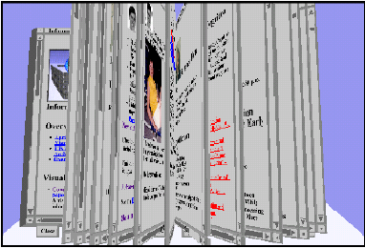
Example:

Example

Example

Example

Example:

Example

Example

Example
Steps:

Steps :

Steps :

Steps :

Steps:

Steps :

Steps :

Steps :
Value

Data Transformation

Analytical Abstraction

Visualization
Transformation

Visualization Abstraction

Visual mapping Transformation

View

Data

Point of view on the data (PVD)

Visualization Space

Point of view on the visualization space (PVS)

a. Chi’s decomposition b. Four steps of a visualization process

a. Ed Chi’s decomposition b. Four steps of a visualization process

a. Ed Chi’s decomposition b. Four steps of a visualization process

a. Ed Chi’s decomposition b. Four steps of a visualization process

a. Chi’s decomposition b. Four steps of a visualization process

a. Ed Chi’s decomposition b. Four steps of a visualization process

a. Ed Chi’s decomposition b. Four steps of a visualization process

a. Ed Chi’s decomposition b. Four steps of a visualization process
http://book.imag.fr/page1.html, ….,
http://book.imag.fr/pageN.html

http://book.imag.fr/page1.html, ….,
http://book.imag.fr/pageN.html

http://book.imag.fr/page1.html, ….,
http://book.imag.fr/pageN.html

http://book.imag.fr/page1.html, ….,
http://book.imag.fr/pageN.html

http://book.imag.fr/page1.html, ….,
http://book.imag.fr/pageN.html

http://book.imag.fr/page1.html, ….,
http://book.imag.fr/pageN.html

http://book.imag.fr/page1.html, ….,
http://book.imag.fr/pageN.html

http://book.imag.fr/page1.html, ….,
http://book.imag.fr/pageN.html

- Chi visualization process.
Data. This step is related to the data to be visualized. For example, as illustrated in Figure 1, the data could be a set of URLs. At this step, we distinguish two types of temporal data: anchored and unanchored temporal data. On the one hand the temporal data characterized as anchored have their temporal field defined and stored explicitly (e.g. the history of an employee’s wage). On the other hand an unanchored temporal field is defined at the execution time such as for multimedia objects (e.g. a video is an unanchored temporal object). For example by considering a video as a succession of images, the associated timestamps are only known at the execution time of the video, according to the images sequencing. The temporal domain of such data can only be calculated as the video is played. We have then considered unanchored data out of the scope of our study. However, our work covers time-stamped unanchored data, such as a time-stamped video (the images of the video are explicitly time-stamped) used for a reviewing task from a security camera or a sports game.
Figure 2 distinguishes the two dimensions of anchored temporal data: structural dimension and temporal dimension. The structural dimension is characterized by a given data type. In particular, we distinguish one-dimensional, two-dimensional, three-dimensional and multi-dimensional data. One-dimensional data could be either quantitative, nominal or ordered as defined by Card and Mackinlay [7]. Two-dimensional data are for example images or geographical maps. Three-dimensional data are for example real world objects. Multi-dimensional data are sets of data consisting of N variables (each variable corresponds to one dimension of the data) that can be completely inter-related or completely independent.
Ordered
Quantitative
Nominal
Planar
Map
Temporal dimension
3D
Temporal data
Structural dimension

ND
2D
1D

- Two dimensions of a temporal data.
Point of view on the data. At this stage of the process, the data are transformed onto an analytical representation. This transformation is generally dependent on the data structures. Indeed the point of view on the data is obtained by defining an analytical abstraction, in other words by obtaining meta-information, information related to the data such as their organization (hierarchical, sequential, etc.) and by filtering the initial data space. For example, in Figure 1, the web pages are retrieved from the list of URLs (initial data space), then an image is generated for each web page.
Visualization space. The visualization space is defined by a transformation of visualization which maps an analytical representation onto values ready to be displayed. In the visualization process shown in Figure 1, the images (the point of view on the data) are ordered (ordered list of images). Moreover, this transformation fixes the characteristics of the graphical space in which the data are visualized in terms of the number of its dimensions.
Point of view on the visualization space. The point of view on the visualization space produces the perceptible rendering. It results from a visual mapping transformation which maps the directly displayable values onto a graphical representation (view). In the example of Figure 1, a book is defined for presenting the list of web pages. So, at the visualization space step, the designer decides on the characteristics of the graphical space. According to these characteristics, the data values of the previous step are mapped onto graphical signs. In addition, at this step, a deformation function (as a fisheye transformation) of the graphical space could be applied, for example to visualize a huge amount of data.
In addition to the decomposition of the visualization process into three types of transformations manipulating four types of data, Chi defines operators. We present some of these operators along the four steps of Figure 1. Operators for the “data” step are for example data filtering, adding new sets of data and the Fourier transformation of images. Operators for the “point of view on the visualization space” step include rotation, translation, enlargement of graphical objects, and the positioning and orientation of a camera in a 3D scene. Other operators are defined for the two steps “point of view on data” and “visualization space”.
Having presented the Chi’s visualization process, we now apply this process to visualize temporal data.

Visualization process of temporal data
As defined above, a temporal data set is an association between two dimensions: a structural dimension and a temporal dimension. Based on these two dimensions, we define the visualization process of a temporal data space as an association between two visualization processes dedicated to the two dimensions of the temporal data (see Figure 2). As a consequence, data complexity of each dimension is treated within the correspondent visualization process. For example, visualizing N-dimensional temporal data may remains at visualizing (N-1) dimensions of the data within the visualization process of the structural dimension and visualizing one dimension (time) with the visualization process of the temporal dimension. In this example, time is considered as one-dimensional.
The visualization process of the structural dimension is dependent on the type of data. Studying this process consists of studying the visualization process of data in general, which is out of the scope of this paper. We therefore only focus on the visualization process of the temporal dimension. Figure 3 shows how we apply the Chi’s visualization process to the temporal dimension of temporal data: four steps are defined namely time, point of view on time, time space and point of view on the time space.
Steps:
Temporal values
Transformation of temporal values
Analytical Abstraction
Visualization
Transformation
Visual mapping Transformation

Time view
Time
Point of view on time
Time space
Point of view on the time space
Visualization Abstraction
Example:
Multi-granular and linear
Month
Year
Day
01/09/2000, 01/10/2000,
01/11/2000, … 02/26/2003

Month
Year
Day
Year

- Visualization process of a temporal dimension.
Time. This step represents the time values to be visualized. Time values are observed according to a time unit as Year, Month, Day, Hour, etc. In the example of Figure 3, time values are observed according to the Day time unit.
Point of view on time. As explained above, this step is defined by the transformation of the time values. This transformation extracts from the time values how time is represented: (i) in which unit system the time values are expressed (ii) are time values linear or periodic? In the example of Figure 3, time is considered as multi-granular and linear. Multi-granular representation refers to time units composition: a year is composed of twelve months, a month is composed of 28, 29, 30 or 31 days, and so on.
Time space. At this step, displayable space of the time values are defined. For example, time values observed at the unit Hour (the analytical representation of “the point of view on time” step), could be mapped onto a matrix. One dimension of the matrix represents the days (Day is a unit coarser than Hour, and regular with Hour), while the other represents the hours. In the example of Figure 3, each time unit is considered as linear: one time axis is then associated to each of them. Moreover at this step, the number of dimensions of the graphical representation in which the temporal values will be visualized is fixed. We distinguish graphical spaces of two dimensions from those of three dimensions. In literature, several works focused on the design of two-dimensional visualization techniques of temporal data as the Cave Plots technique [4], the Multi-scale Timeline technique [47] or the Information Mural technique [31]. However, in the last few years due to the advances in 3D technologies, a particular interest is given to the design of three-dimensional visualization techniques of temporal data as for the Time Tube technique [11] and the Data Tube technique [2].
Point of view on the time space. The point of view on the time space refers to the perceptible rendering of the temporal dimension. At this step, the perceptible forms or representations of time are implemented. These representations must be studied according to the human perception of time. For instance, as pointed out by Tufte [56, p. 186 ], human eyes are able to detect deviation of the horizon, making easier the perception and interpretation of the horizontal representations of temporal data.
The choice of a representation is strongly influenced by the point of view on time that has been adopted (Step 2 “Point of view on time”). Indeed, the point of view on time identifies the characteristics of the temporal values to be visualized. For example, a graphical representation of time in a cyclic form as illustrated by the spiral shown in Figure 4a could be used because the temporal values are periodic: periodicity is a characteristic that has been identified during the step “Point of view on time”. The Figure 4a shows data on the consumption of Baphia Capparidifolia by chimpanzees in the Gombe preserve in Tanzania for the years 1980 through 1988. Data values are mapped into blue colored graphical objects (filled circles): the size of these circles show the difference in the quantity of the consumption at each month. Figure 4b (a simplified representation of the TimeSlider technique [33]) illustrates yet another representation of time where points of time are distributed irregularly on an axis in order to render a logarithmic perception of time [13]. As shown in Figure 4b, time scale is linear at the center part of the timeline (time step is uniform and equal to one time unit, a day in Figure 4b) whereas it is non-linear (time step is exponential) at the ends. Time may be viewed as linear as depicted in Figure 3. In the example of Figure 3, four timelines [21] are used to interact with the time space: one timeline for each time unit (Year, Month and Day) and one timeline to present an overview of the selected time values.
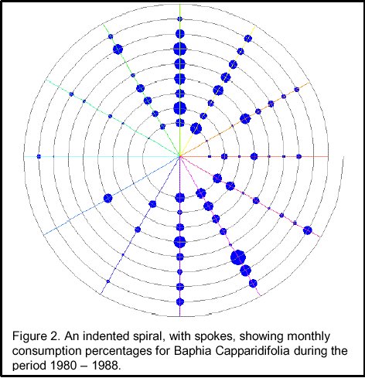
a. Spiral representation of time [8]
b. Logarithmic representation of time, inspired from the TimeSlider technique [33]
Time scale
linear
Non linear
Non linear
3
9
14
18
20

22
23
24
25
26
27
28
3/1
2
3
5
7
11
16
22
2

- Time representations.
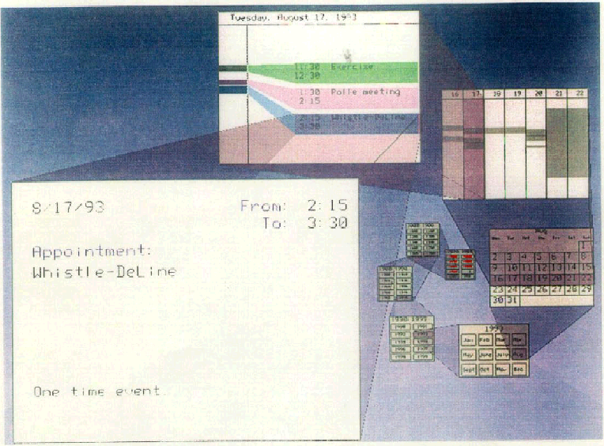Some visualization techniques of temporal data rely on several forms of time used simultaneously. The Spiral Calendar Visualizer technique [41] shown in Figure 5, includes two points of view on time: multi-granular and cyclic. In Figure 5, the values of each time unit are represented as a calendar (multi-granular representation of time). Thus, years are first represented in a view, then one year (1993 in the example of Figure 5) is displayed in another view and a month of this year is displayed in another view and so on. All the views are represented in a spiral form (cyclic perception of time). Using simultaneously these two forms of time reinforces the user’s perception of the multi-granular structure of time while highlighting cycles.

- Spiral Calendar Visualizer [41].

A taxonomy based on the steps of the visualization process
In the previous paragraph, we presented the visualization process of the temporal dimension. However a temporal data is an association of two dimensions: a structural dimension and a temporal dimension. Our taxonomy of temporal data visualization techniques is then based on the different anchoring points between the two visualization processes: one dedicated to the temporal dimension (as described in the previous paragraph) and one dedicated to the structural dimension.
Considering the different anchoring points between the two visualization processes enables us to define seven classes of visualization techniques, described in Figure 6. The configurations depicted in Figure 6 vary in between two opposite cases: one corresponds to the complete fusion of two processes (Figure 6a) and the other corresponds to the complete splitting of the two processes (Figure 6g).
a
Temporal data
f
Data
Time
g
Data
Time
Data
Time
b
c
Data
Time

e
Data
Time
d
Data
Time
Data

Point of view on the data (PVD)

Visualization Space

Point of view on the visualization space (PVS)

- Five classes of temporal data visualization techniques according to their visualization process.
A point of contact (i.e., the first common step) between the two visualization processes is defined according to the operators that are applied at the corresponding step. The operators, as defined by Chi, are specific to each of the four visualization process steps. For example translation or rotation are operators dedicated to the step “point of view on the visualization space”. If at a given step, one operator has an impact on the data manipulated by the two processes then we consider that the corresponding step is the point of contact. One operator is a sufficient condition to declare the corresponding step point of contact. It is worth noting that some operators may remain specific to only one of the two processes. Once a step is defined as the point of contact, all the following steps in both processes are then merged. To the best of our knowledge there does not exist any approach corresponding to the configuration of Figure 7.
Data
Time

- The separation of the two visualization processes after a crossing-point.
Total fusion or fusion at the step “point of view on the data”. Some visualization techniques of temporal data result from a complete fusion of the two visualization processes. We distinguish two cases described in Figure 6a and Figure 6b. The configuration depicted in Figure 6a is often used to visualize data whose temporal field is not anchored. In this case, the representation of time is implicit. Examples include playing videos, or visualizing data captured in real time. By opposition, the configuration shown in Figure 6b is used to visualize temporal data whose temporal field is anchored. Time is then explicit, enabling us to distinguish the two dimensions of temporal data, the temporal and structural ones. Visualization techniques could then be split depending on whether the time representation is explicit (Figure 6b) or implicit (Figure 6a).
The first class gathers together the techniques which includes an explicit representation of time. For example, the diagram representations which are usually used to visualize quantitative data or temporal intervals and temporal relations [37, 49]. In this type of representations, time is often represented on the horizontal axis and data values on the vertical axis. In the example of Figure 8, we consider the air pollution measures over time of NO (nitric oxide) and NO2 (nitrogen dioxide). Structural values are represented as a curve.
Time
Data values
NOconcentration
NO2concentration

- Curve Representation.
Figure 9 presents the visualization process (configuration b of Figure 6) of the curve representation: the visualization process of the temporal dimension (as described in the previous section) and that of the structural dimension are crossing at the step “point of view on the data”. Consequently, the representation of the structural dimension (the curve) and that of the temporal dimension (the time axis) are in the same graphical space. In the example of Figure 8, the two dimensions of the temporal data are visualized within a two-dimensional graphical space. In the visualization process of the temporal dimension of Figure 9, time is implicitly considered as linear. The linear perception of time is used to guide the design of the representation of time values as an axis.
Point of view on the visualization space

Time
Curve representation
Visualization space
Point of view on the data
Curve
Quantitative
Structural dimension
NO or NO2
Temporal values

- Visualization process of Curve Representation.
The second class groups the visualization techniques whose representation of the temporal dimension is not explicit. A few visualization techniques of anchored temporal data do not consider an explicit representation of time. We distinguish two categories of techniques that belong to this class: dynamic representations (in literature, known as animated techniques) vs static representations. The former groups techniques for which the visual representation is time-dependent: it changes dynamically and is a function of time. Campos and al. [6] propose an animation model to support exploratory analysis of dynamic environments. Animation is frequently used to visualize spatio-temporal data as with the TimeMap data viewer [30]. The later groups techniques for which the visual representation is not time-dependent. In other terms, the visual representation does not change automatically over time.
The information mural technique [31] is a static representation of temporal data that belongs to this class. It allows us to visualize a large data space: the number of data values is greater than the number of pixels available in the screen. This technique aims at transforming the initial data space which is defined with M*N pixels into a smaller space of I*J pixels while preserving a similar global view of the initial data space. Based on this technique, Figure 10 presents a visualization of the number of daily recorded sun spots observed between 1850 and 1993 which is over 52,000 readings. The transformation is applied to the structural dimension only and not on the temporal dimension in order to preserve the view of the initial data space. The idea is to provide an overview of the data tendency, neglecting a precise value associated to a particular point of time. In this case, the visualization process of the temporal data corresponds to the visualization process of the structural dimension. As a temporal dimension is not explicitly represented, both the “time space” and the “point of view on the time space” steps of the temporal dimension visualization process are not considered.

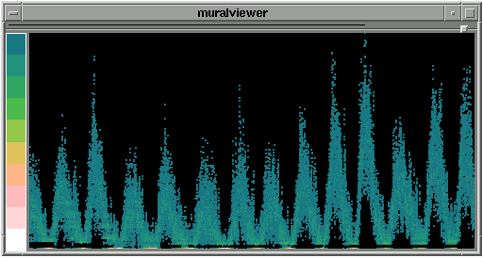

- Information Mural [31].
Fusion at the step “visualization space”. The fusion of the two visualization processes at the step “visualization space” (Figure 6c) implies that the graphical space in which the structural dimension is represented depends on the temporal dimension. Thus, the characteristics of the graphical space of the temporal dimension and some operators applied on this dimension, directly affect the graphical space of the structural dimension, and conversely. We distinguish two classes of visualization techniques defined by the process of Figure 6c according to whether the graphical space of the structural dimension is merged with the graphical space of the temporal dimension, or not.
In the first class, there is one single space representing the two dimensions. If the temporal dimension (respectively the structural dimension) is represented in a three-dimensional space, the structural dimension (respectively the temporal dimension) must then be represented in a three-dimensional space. As the two graphical spaces are merged, the visual discontinuity between the two dimension representations is reduced. The Spiral representation [46] of Figure 11 is an example of technique that belongs to this group, its visualization process is presented in Figure 12. Figure 11 shows a visualization of program traces over time.
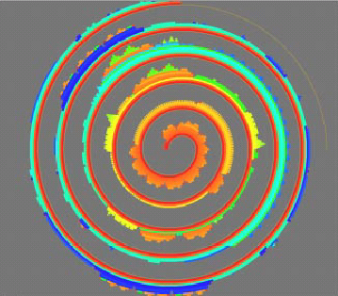
- Spiral representation [46].
As shown in Figure 12, the visualization process of the structural dimension (on the left in Figure 12) and that of the temporal dimension (on the right in Figure 12) are crossing at the visualization space step. In the visualization process of the temporal dimension of Figure 12, only the cyclic perception of time is considered at the point of view on time step. Consequently time is represented as a spiral. As we can see from Figure 11, the structural dimension and the temporal dimension are visualized into the same graphical space, in particular a two-dimensional graphical space.
Point of view on the visualization space

Point of view on time
Time
Spiral representation
Visualization space
Point of view on the structural dimension
Spiral
Quantitative
Structural dimension
Program traces
Cyclic
Temporal values

- Visualization process of the Spiral representation.
In the second class of techniques, the two dimensions are represented separately in the same graphical space. For example, our TimeVis technique of Figure 13 distinguishes the representation of the time from the representation of the structural values. Time and structural values are separately represented but in the same graphical space. As for the example given in Figure 11, rotating the representation (graphical space) of the temporal dimension (the perspective wall timeline in the example of Figure 13) implies a rotation of the representation (graphical space) of the structural dimension. In the example of Figure 13, the TimeVis technique shows the history of the investments (in millions dollars) of one country in agriculture, services, industries and infrastructures.
Agriculture : 260M
Services : 203M
Industries : 380M
Infrastructures : 630M

Agriculture : 258M
Services : 290M
Industries : 650M
Infrastructures : 520M

Agriculture : 250M
Services : 180M
Industries : 460M
Infrastructures : 580M

Agriculture : 258M
Services : 270M
Industries : 450M
Infrastructures : 550M

Agriculture : 200M
Services : 120M
Industries : 450M
Infrastructures : 550M

- TimeVis technique.
Fusion at the step “point of view on the visualization space”. This case is represented in Figure 6d. This configuration of the two visualization processes is impossible because the structural values are always associated with the temporal values, which implies that the point of view on the visualization space of the structural dimension is defined only once the point of view on the time space is defined. Thus, the two points of view on the visualization spaces must be fixed sequentially, considering first the time and then the structural values. Respecting this ordering constraint we identify two cases depicted in Figure 6e and Figure 6f.
Time and then the step “visualization space of the structural dimension”. Some visualization techniques of temporal data use the representation (graphical space) of the temporal dimension as a support for the representation of the structural dimension. The main advantage is the direct association of structural values with the corresponding temporal values. This direct association reduces (or even eliminates) the visual discontinuity between both representations. As a result, the temporal values and the structural values are visualized in the same graphical space. First, the characteristics of this graphical space are all fixed by the temporal dimension and second, the structural values are then visualized within this space. If time is represented in a two-dimensional space, the structural values will be too. For this reason, the representation of the structural dimension is defined once the visualization process of time is completely achieved (see Figure 6e). It is worth noting that this configuration is different from that where the fusion proceeds at the “visualization space” step (see Figure 6c). Indeed, based on this configuration, the visualization process of the temporal dimension is completely independent of that of the structural dimension. This later could be modified or replaced by another one while keeping the same visualization process of the temporal dimension.
The Superposed Histograms Technique (SHT) [15] of Figure 14 illustrates this configuration of visualization process. In SHT, data values (air pollution measures of NO and NO2 in the example of Figure 14) have been mapped to 2.5D graphical objects (in the form of cubes). Time is represented along two dimensions. For this reason, the SHT includes two time-sliders, one vertical and one horizontal. Each data value is the result of a function f with two parameters that are two regular time-units. One time-unit U1 is said to be regular with regard to another time-unit U2, only if each value of U1 is composed of a fixed number of U2. A concrete example of regular units is year and month. Each year contains twelve months. In the example of Figure 14, years and months are mapped onto two axes: years along the vertical axis and months along the horizontal axis. Each data value corresponds to f (year, month).
As shown in Figure 15, we distinguish two visualization processes: one dedicated to the temporal dimension and one dedicated to the structural dimension. The visualization process of the temporal dimension of the SHT (on the right in Figure 15) is completely achieved independently from that of the structural dimension (on the left in Figure 15), whereas the opposite is not no true.
In the visualization process of the temporal dimension of Figure 15, two time perceptions are considered at the point of view on time step: multi-granular and linear perceptions. The linear perception of time is used to guide the design of the perspective wall timeline, whereas the multi-granular perception implies the use of two timelines: one to represent hours horizontally and one to represent days vertically.

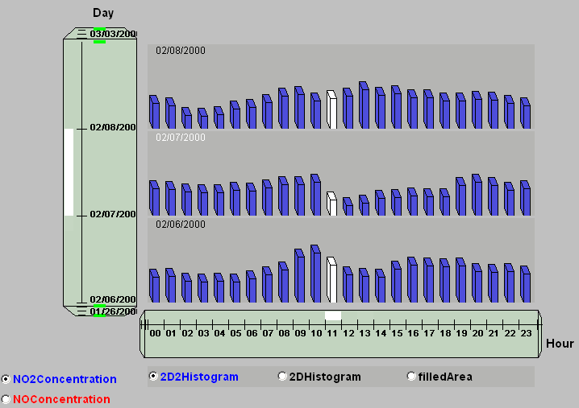

- Superposed Histograms technique [15].
The visualization process of the structural dimension of the SHT is presented on the left in Figure 15. During the visualization space step, a histogram representation is used to denote the evolution of the visualized data. The choice of the histogram representation is strongly influenced by the fact that the data are quantitative. Moreover, histograms are visualized within a two-dimensional graphical space. In fact, as shown in Figure 15, the structural space is defined with respect to the characteristics fixed within the time space step (the arrow coming from the point of view on time space to the structural space). In the SHT technique time is represented within a two dimension graphical space.
Point of view on the visualization space

Point of view on the time space
Time space
Point of view on time
Time
Temporal values
Perspective wall form
Two perspective wall representations
Superposed Histograms Technique
Structural space
Point of view on the structural dimension
Histogram form
Quantitative
Structural dimension
NO or NO2
Linear
Two dimensions of the time space
Multi-granular

- Visualization process of Superposed Histograms Technique.
Time and then the step “point of view on the visualization space of the structural dimension”. The process corresponding to this case is shown in Figure 6f. The temporal dimension is visualized in a graphical space independent of the structural dimension. On the one hand this distinction allows an explicit separation between the user tasks referring to each of the two dimensions of temporal data, for example by navigating in time versus navigating along the structural dimension. On the other hand visual discontinuity is possible, for example making difficult the identification of a value at a given time. The Star Representation Technique (SRT) [17] of Figure 16 illustrates the process of Figure 6f.
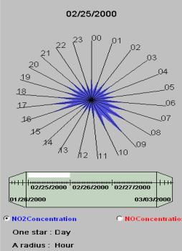
Perspective Wall Timeline
Star representation

- Star representation technique [17].

As shown in Figure 17, we distinguish two visualization processes: one dedicated to the temporal dimension and one dedicated to the structural dimension. The visualization process of the temporal dimension of the SRT (on the right in Figure 17) is completely achieved independently from that of the structural dimension (on the left in Figure 17), whereas the opposite is not no true.
As shown in Figure 16, the SRT technique relies on two forms of time used simultaneously (the perspective wall timeline and the star representation). In the visualization process of the temporal dimension of Figure 17, three time perceptions are considered at the point of view on time step: multi-granular, linear and periodic perceptions. The multi-granular perception is used to distinguish hours and days. The linear perception of time is used to visualize days as a perspective wall timeline, whereas the periodic perception is used to visualize hours of a day and thus to design the structural space, the star representation of Figure 16. In Figure 16, a star denotes a day whereas the radii denotes the twenty four hours of a day.
The visualization process of the structural dimension of the SRT is presented on the left in Figure 17. During the visualization space step, a star representation is used to denote the evolution of the visualized history during a fixed-length period of time. The choice of the star representation is strongly influenced by the fact that we considered the periodic perception of time to define the visualization space (the arrow coming from the point of view on time to the structural space) and by the fact that the data are quantitative (the NO and NO2 concentrations). The star representation could be visualized within a two dimension graphical space as in the example of Figure 16 or within a three dimension graphical space. By opposition to the superposed histograms technique of the precedent paragraph, as shown in Figure 15, the structural space is defined independently from the characteristics of the time space. In fact, there is no connection between either the time space or the point of view on time space where the characteristics of the graphical space are fixed, and the to structural space.
Point of view on the visualization space

Point of view on the time space
Time space
Point of view on time
Time
Perspective wall form
Perspective wall representation
Periodic
Star Visualization Technique
Structural space
Point of view on the structural dimension
Quantitative
Structural dimension
NO or NO2
Linear
Temporal values
Star form
Multi-granular

- Visualization process of Star Visualization Technique.
Process completely separated. Such a configuration (Figure 6g) is impossible as the structural values are always associated with the temporal values.

Discussion and future work
As the temporal dimension is designed independently from the structural dimension in the visualization processes of Figure 6e and Figure 6f, our resulting perspective wall timeline (produced by the visualization process of temporal dimension) has been reused in the Superposed Histograms Technique and the Star Representation Technique. Consequently we can use a dedicated physical device [16] (as shown in Figure 18) for the perspective wall timeline, making the reusable corresponding software component a reusable physical device. Our physical device corresponds to the perspective wall timeline associated with a handheld computer. The Star Representation Technique will consequently be multi-surface, one for the temporal dimension and one for the structural dimension. This is more complicated to implement for the Superposed Histograms Technique because it uses two timelines to represent the time space. Perhaps, it is not possible to use the physical device with the Curve Representation of Figure 8: the fusion of the two visualization processes is at the step “point of view on the data”. The representation of the structural dimension and that of the temporal dimension are then in the same graphical space. Consequently, they are visualized on the same display, a screen for example.

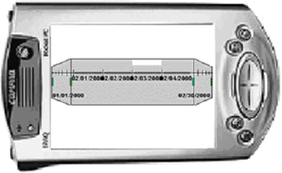

- Physical device to interact with the temporal dimension [16].
Our taxonomy based on the visualization process steps is useful for systematically exploring the set of possibilities as well as for thoroughly envisioning visualization techniques of temporal data. Indeed we classified in the table of Figure 19 several existing techniques according to our taxonomy. As it is shown, most of the existing techniques fit into the three first cases (Figure 6a, 6b and 6c) of our taxonomy (lines 1 and 2 in the table of Figure 19). It is therefore interesting to further explore and envision new visualization techniques that would fit in the two other classes identified in our taxonomy (the two last lines of the table of Figure 19).
1 | Total fusion or fusion at the step “point of view on the data” (Figure 6a and Figure 6b) | Diagram representation: [25] [34] [54] [26], timeHistograms [48], Map of Napolean's Army's Russian Campaign [56], Information Mural [31], DataWear [12], TimeSearcher [29], TimeWeel [55], MultiComb [55], Temporal Network Visualizer [18], TimeMap data viewer [30], temporal star representation [38].
2 | Fusion at the step “visualization space”  (Figure 6c) | Time Tube [11], Calendar representation [58], Dynamic Timelines [50], Spiral [57], Spiral [46], Worlds Within Worlds [23], Spiral Calendar Visualizer [41], SpiraClock [20], multi-scale Timeline [47], TimeScape [45], BITS [19], timeline [53], Data Tube [2], CalendarView of DataJewel system [1], circle-segment technique [32].
3 | Time and then the step “space of the structural dimension” (Figure 6e) | Spiral representation [8], Perspective Wall [40], ThemeRiver [27], Concentric Circles Technique [14], Superposed Diagrams technique [15].
4 | Time and then the step “point of view on the space of the structural dimension” (Figure 6f) | LifeLines [43], OITL [5], Star representation technique [17].

- Visualization techniques of temporal data.
Our taxonomy of temporal data visualization techniques is based on the possible points of contact between two visualization processes, one dedicated to the temporal dimension and one to the structural dimension. This study could be generalized to any type of data by considering the visualization of two data spaces or coordinated and multiple views of the same data space. However, for the case of temporal data, the two data spaces are linked: indeed the structural values are stamped by temporal values. For the case of two independent data spaces, additional configurations should be considered. For instance, the configuration of Figure 6d which is impossible for temporal data, becomes possible for two independent data spaces.

References
- Ankerst M., Jones D.H., Kao A., Wang C. DataJewel: Tightly Integrating Visualization with Temporal Data Mining. ICDM Workshop on Visual Data Mining, Melbourne, FL, 2003.
- Ankerst M. Visual Data Mining with pixel-oriented Visualization Techniques. ACM SIGKDD Workshop on Visual Data Mining, San Francisco, CA, 2001.
- Antunes Claudia and Oliveira Arlindo L., Temporal Data Mining: an Overview. In KDD Workshop on Temporal Data Mining, August 2001.
- Becker Richard A., Clark Linda A. et Lambert Diane. Cave Plots: A Graphical Technique for Comparing Time Series. Journal of Computational and Graph. Stat., 1994.
- Bui Alex A.T., Aberle Denise R., McNitt-Gray Michael F., Cardenas Alfonso F., Goldin Jonathan, et M.D. The Evolution of an Integrated TimeLine for Oncology Patient Healthcare. Annual symposium of Amia, November 10, 1998.
- Campos Jorge, Egenhofer Max J. and Hornsby Kathleen. Animation model to Support Exploratory Analysis of Dynamic Environments. In proceedings of Summer Computer Simulation Conference (SCSC), Canada
pp.761-766, July 2003.
- Card Stuart K. and Mackinlay Jock. The Structure on the Information Visualization Design Space. Proceedings of the 1997 IEEE Symposium on Information Visualization (InfoVis '97).
- Carlis J.V. and Konston J.A. Interactive Visualisation of Serial Periodic Data. In proceedings of the ACM Conference on User Interface Software and Technologie UIST´98, San Francisco, Ca, 1998.
- Chi Ed H. A Taxonomy of Visualization Techniques using the Data State Reference Model. Proceedings of InfoVis 2000 (Salt Lake City UT, October 2000), IEEE Computer Society.
- Chi Ed H. Expressiveness of the Data Flow and Data State Models in Visualization Systems. In Proc. of the Advanced Visual Interfaces Conference, ACM Press, May 2002, Italy.
- Chi Ed H., Pitkow James, Mackinlay Jock, Pirolli Petre, Gossweiler Rich, et Card Stuart K. Visualizing the Evolution of Web Ecologies. Proceedings of the Conference on Human Factors in Computing Systems CHI'98.
- Chris North, Umer Farooq, and Dilshad Akhter. DataWear: Revealing Trends of Dynamic Data in Visualizations. In proceedings IEEE Symposium on Information Visualization 2001 (InfoVis 2001).
- Church Russell M. Evaluation of Quantitative Theories of Timing. Journal of the experimental analysis of behavior. Number 2, March 1999.
- Daassi Chaouki, Dumas Marlon, Fauvet Marie-Christine, Nigay Laurence et Scholl Pierre-Claude. Visual exploration of temporal object databases. In proceedings of BDA 2000. (24-27 Octobre, Blois, France).
- Daassi Chaouki, Fauvet Marie-Christine, Nigay Laurence. Visual Mining: Representation Multiplicity of Temporal Data. In proceedings of DEXA, Septembre 2-6, 2002, Aix-en-Provence, France.
- Daassi Chaouki, Nigay Laurence and Fauvet Marie-Christine. Composant logiciel vs physique pour interagir avec un espace de valeurs temporelles. French Conference on Human Computer Interaction (IHM), Namur, Belgium, 2004.
- Daassi Chaouki, Nigay Laurence and Fauvet Marie-Christine. Visualization process of Temporal Data. In proceedings of DEXA Conference, Spain, 2004.
- Davies Eric J. and Cowan William B. Visualizing Causality. In proceedings of the Symposium on visualizing Time-Varying Data., 1999.
- Dias Antonio Eduardo, Silva João Pedro et Câmara Antonio S. BITS: Browsing In Time and Space. In proceedings of CHI’95, May 7-11 1995, Denver Colorado, papier court.
- Dragicevic Pierre et Huot Stéphane. SpiraClock : A Continuous and Non-Intrusive Display for Upcoming Events. In proceedings of CHI’02. 2002.
- Dumas M., Daassi C., Fauvet M-C, Nigay N. "Pointwise Temporal Object Database Browsing". In Proc. Of ECOOP, France, 2000.
- Fauvet M-C. Dumas M., and Scholl P-C. A representation independent temporal extension of ODMG´s Object Query Language. In proceedings of BDA’99 Conference, Bordeaux, France, October1999.
- Feiner Steven et Beshers Clifford. Worlds within Worls : Metaphors for Exploring n-Dimensional Virtual Worlds. Proceedings of UIST’90, Snowbird, UT, October 3-5, 1990.
- Frédéric Vernier. La multimodalité en sortie et son application à la visualisation de grandes quantités d’information. PhD thesis in Computer Science from Joseph-Fourier University of Grenoble, France. 2001.
- Fredrikson A., C. North, C. Plaisant, and B. Shneiderman. Temporal, Geographical and Categorical Aggregations Viewed through Coordinated Displays : A Case Study with Highway Incident Data. HCIL Technical Report No. 99-31, December 1999.
- Hao Ming C., Ladisch Julian, Dayal Umeshwar, Hsu Meichun, et Krug Adrian. Visual Mining of E-Customer Behavior Using Pixel Bar Charts. HP Labs Technical Reports, 2001.
- Havre Susan, Hetzler Beth and Nowell Lucy. ThemeRiver: Visualizing Theme changes over Time. Proceedings of the IEEE Symposium on Information Visualization 2000.
- Hochheiser Harry, Ben Shneiderman. Using Interactive Visualizations of WWW Log Data to Characterize Access Patterns and Inform Site Design. In proceedings of Journal of the American Society of Information Science and Technology, Vol. 52, No. 4, 2001.
- Hochheiser Harry, Interactive Querying of Time Series Data. In proceedings of CHI 2002, Avril 20-25, Minneapolis, Minnesota, USA.
- Ian J. et Wilson A. The TimeMap Project: Developing Time-Based GIS Display for Cultural Data. Journal of GIS in Archaeology Vol 1. ESRI Inc., Redlands. 2002. Available at: http://www.archaeology.usyd.edu.au/.
- Jerding Dean F. et Stasko John T. The Information Mural : A Technique for Displaying and Navigating Large Information Spaces. Technical Report GIT-GVU-97-24, Graphics, Visualization, and Usability Center, Georgia Institute of Technology.
- Keim Daniel A. Pixel-Oriented Databases Visualization. SIGMOD Record, special issue on “information visualization”, December 1996.
- Koike Yuichi, Sugiura Atsushi et Koseki Yoshiyuki. TimeSlider : An Interface to Specify Time Point. In proceedings of UIST 1997, Alberta Canada.
- Kosara Robert et Miksch Silvia. A Visualization of Medical Therapy Plans compared to Gantt and PERT Charts. Proceedings of the Seventh International Workshop on Temporal Representation and Reasoning (TIME-00), IEEE Computer Society, 2000.
- Kramer T. and Jozsa J. Visualization and analysis of time-dependent hydrometric data in windows environment. In proceedings of Hydroinformatics, August 1998.
- Kumar Vijay, Furuta Richard and Allen Robert B. Metadata visualization for digital libraries: interactive timeline editing and review. In proceedings of The International Conference On Digital libraries, 1998.
- Luca Chittaro and Carlo Combi. Representation of Temporal Intervals and Relations: Information Visualization Aspects and their Evaluation. In Proceedings of TIME-01: 8th International Symposium on Temporal Representation and Reasoning, IEEE Press, 2001.
- M. Noirhomme-Fraiture. Visualization of Large Data Sets: The Zoom Star Solution. In proceedings of The Electronic Journal of SYMBOLIC DATA ANALYSIS – Vol.0 N. 0 (2002).
- MacEachren Alan M., Boscoe Francis P., Haug Daniel, Pickle Linda W. Geographic Visualization: Designing Manipulable Maps for Exploring Temporally Varying Georeferenced Statistics. Proceedings of Information Visualization, Oct. 19-20, 1998.
- Mackinlay Jock D., Robertson George G. and Card Stuart K., The Perspective Wall : Detail and Context Smoothly Integrated. Proceedings of the CHI `91, ACM Press.
- Mackinlay Jock D., Robertson George G., et DeLine Robert. Developing Calendar Visualizers for the Information Visualizer. In proceedings of UIST 1994.
- Müller Wolfgang and Schumann Heidrun. Visualization methods for Time-Dependent Data- An Overview. Proceedings of the Winter Simulation Conference, 2003.
- Plaisant C., Milash B., Rose A., Widoff S. and Shneiderman Ben. LifeLines : Visualizing Personal Histories. In proceedings of CHI’96. Vancouver, BC, Canada, April 13-18, 1996.
- Rainsford Chris P. and Roddick John F. Visualisation of Temporal Association Rules. In proceedings of 2nd International Conference on Intelligent Data Engineering and Automated Learning (IDEAL), 2000.
- Rekimoto Jun. Time-Machine Computing : A Time-centric Approach for the Information Environment. Proceedings of UIST '99, ACM Symposium on User Interface Software and Technology, November 1999.
- Renieris M. et Reiss S. P. ALMOST : Exploring Program Traces. NPIVM' 99 Workshop, Kansas City, MO, November 6, 1999.
- Richter H., Brotherton J., Abowd G. D., et Truong K. A Multi-Scale Timeline Slider for Stream Visualization and Control. GVU Center, Georgia Institute of Technology, Technical Report GIT-GVU-99-30, June 1999.
- Robert Kosara, Fabian Bendix, Helwig Hauser. TimeHistograms for Large, Time-Dependent Data.
Joint Eurographics - IEEE TCVG Symposium on Visualization (VisSym 2004), forthcoming 2004
- Robert Kosara, Silvia Miksch. Visualizing Complex Notions of Time. Proceedings of the Conference on Medical Informatics (MedInfo 2001), 2001.
- Robin L. Kullberg, Dynamic Timelines: Visualizing Historical Information in Three Dimensions. Master Thesis from Media Lab. MIT, 1995.
- Shneiderman Ben, The Eyes Have It: A Task by Data Type Taxonomy for Information Visualizations , CS-TR-3665 July 1996, ISR-TR-96-66.
- Silva S. F. and Catarci T. Visualization of Linear Time-Oriented Data: a Survey. First Interational Conference on Web Information Systems Engineering (WISE), 2000.
- Stolte C., Bosch R., Hanrahan P., and Rosenblum M. Visualizing Application Behavior on Superscalar Processors. In proceedings of Information Visualization, San Francisco Airport Hyatt, San Francisco, CA. October 24 - October 29, 1999.
- Theus M. Trellis Displays vs. Interactive Graphics. Advances in Statistical Software 5, Softstat '95, eds. Frank Faulbaum & Wolfgang Bandilla, Lucius & Lucius, Stuttgart, 1996.
- Tominski C., Abello J. and Schumann H. Axes-Based Visualizations with Radial Layouts. In proceedings of the ACM symposium on Applied computing, 2004.
- Tufte E. R., The Visual Display of Quantitative Information, Graphics press, 1983.
- Weber Marc, Alexa Marc et Müller Wolfgang. Visualizing Time-Series on Spirals. Proceedings on InfoVis 2001.
- Wijk Jarke J. Van et Selow Edward R. Van. Cluster and Calendar based Visualization of Time Series Data. IEEE Symposium on Information Visualization (InfoVis’99), San Francisco, October 25-26, 1999.
- Yuval Shahar and Cleve Cheng. Intelligent Visualization and Exploration of Time-Oriented Clinical Data. In Proceedings of Topics in Health Information Management, 1999.
- Yuval Shahar and Cleve Cheng. Model-Based Visualization of Temporal Abstractions. In Proceedings of Computational Intelligence, 2000.

One time-unit U1 is said to be regular with regard to another time-unit U2, only if each value of U1 is composed of a fixed number of U2. The time unit U1 is said to be coarser than the time unit U2, and U2 is finer than U1. A concrete example of regular units is Year (coarser unit) and Month (finer unit). Each year contains twelve months.

